ASSIGNMENT  
Shivam Navnath Giri

CDAC SILCHAR - PGDAI

1. Create a Jenkins Job in a
2. freestyle Type

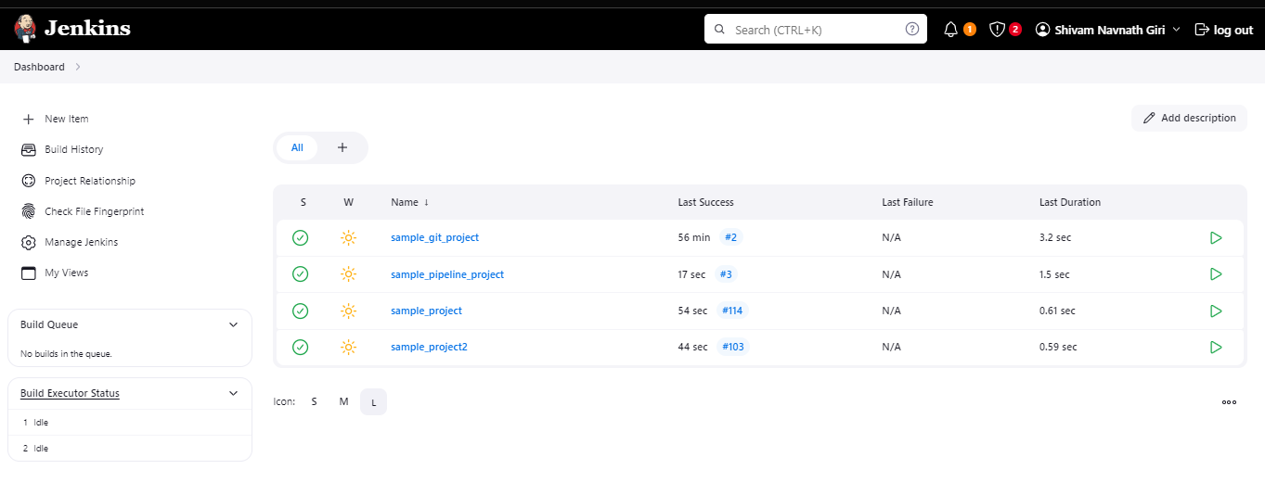

Q. Demonstrate the following

(i) Build Triggers w.r.t SCM

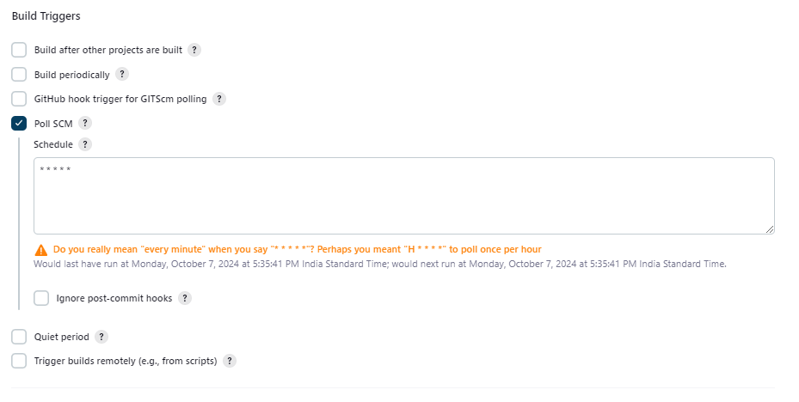

1. Integration with Git

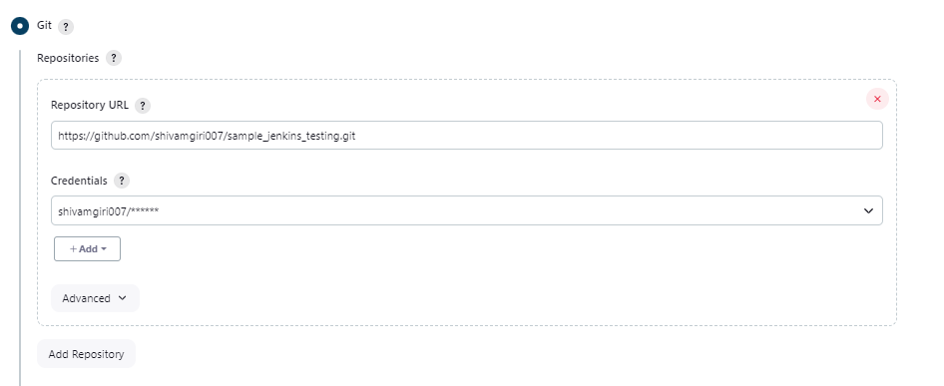

Create a Repository on Git and connect the created branch b1 with the Jenkins and ensure the automation on the build via any changes pushed to the github.

